Winter
Find and circle all of the words that are hidden in the grid.
The words may be hidden in any direction.
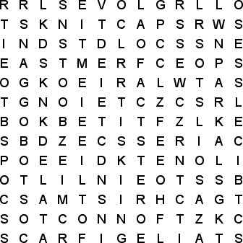
BLIZZARD  BOOTS  CHRISTMAS  COLD  FREEZE  FROST  GLOVES |  | ICE  ICICLES  KNIT CAP  MITTENS  PARKA  SCARF |  | SKATES  SKIING  SLED  SLEET  SNOW  TOBOGGAN

