Presidential Trading Cards
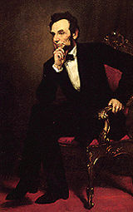 | Abraham Lincoln  Years he was President: 1861-1865  State Represented: Illinois  Party Affiliation: Republican  Fact(s): He had to struggle for a living. Lincoln's mom died when he was 9. He loved to read.
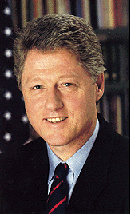 | William Clinton  Presidential Number: 42nd  Years he was President: 1993-2001  State Represented: Arkansas  Party Affiliation: Democrat  Fact(s): He was the only president from Arkansas. He played the saxophone. While in high school, he once met President John Kennedy in the White House.
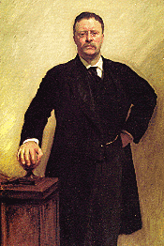 | Theodor Roosevelt  Presidential Number: 26th  Years he was President: 1901--1909  State Represented: New York  Party Affiliation: Republican  Fact(s): Born and died in New York. First president to ride in a car while president.

