DIFFERENT TYPES OF JOBS THAT BOTH MAN & WOMAN CAN DO
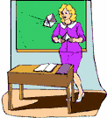 | TEACHER
 | DOCTOR
 | POLICEMAN,  (POLICE OFFICER)
 | FIREMAN
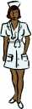 | NURSE
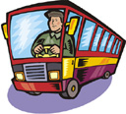 | BUS DRIVER
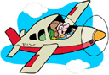 | POLIT
 | WAITER
 | MAILMAN (POSTMAN)
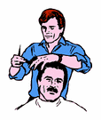 | BARBER
 | STUDENT
 | COOK (CHEF)
 | WAITRESS
 | HAIRDRESSER
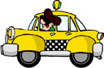 | TAXI DRIVER
 | SECRETARY
 | BUSINESSMAN
 | CLEANER
 | CASHIER (SALES ASSISTANT)
 | FACTORY WORKER
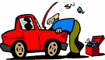 | MECHANIC

