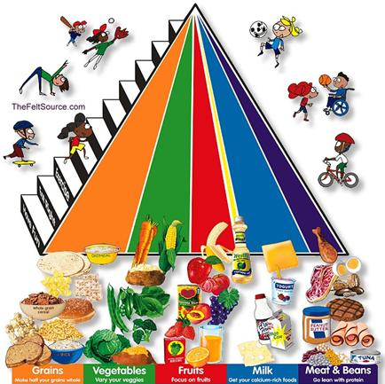

Grains: 5 oz. everyday: bread, cereals, rice, pasta, crackers

Vegetables: 2 ½ cups everyday: broccoli, peas, corn, carrots, green beans

Fruits: 1 ½ cups everyday: apples, oranges, bananas, pears, berries

Milk: 3 cups everyday: milk, yogurt, cheese, frozen yogurt

Meat & Beans: 5 oz. everyday: beef, chicken, fish, eggs, nuts