New York State
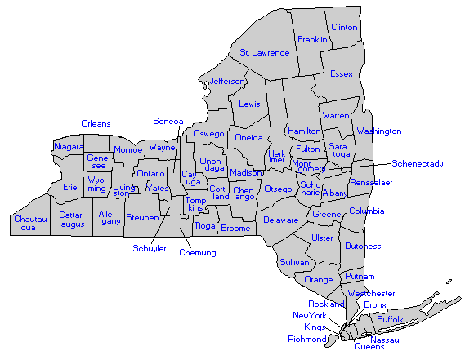 | - This is the State of New York.  - “New York was the 11th state to enter the Union, on July 26, 1788.”  - In 1624, the Dutch were the first people to settle permanently in New York.  http://www.dos.state.ny.us/kidsroom/nysfacts/factmenu.html
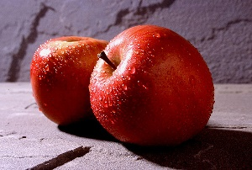 | - The State fruit of New York is the apple.  - The apple was adopted as New York’s fruit in 1976.  http://www.dos.state.ny.us/kidsroom/nysfacts/factmenu.html
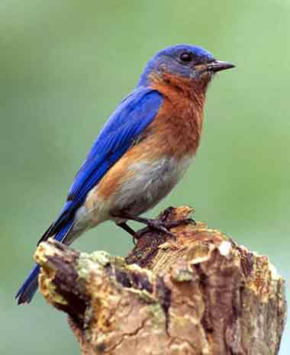 | - The State bird of New York is the bluebird.  - The bluebird was adopted as New York’s bird in 1970.  http://www.dos.state.ny.us/kidsroom/nysfacts/factmenu.html
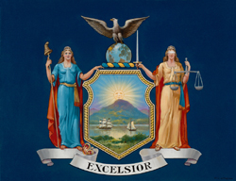 | - “The arms of New York State were officially adopted in 1778.”  - The banner shows New York States motto, Excelsior.  - Excelsior means “Ever Upward.”  http://www.dos.state.ny.us/kidsroom/nysfacts/factmenu.html
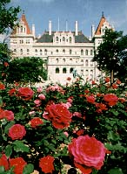 | - New York State’s capital is in Albany.  - Albany became New York State’s capital in January 1797.  http://www.dos.state.ny.us/kidsroom/nysfacts/factmenu.html

