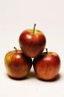 | Apples
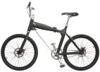 | Bike
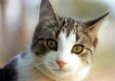 | Cat
 | Dog
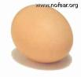 | Egg

