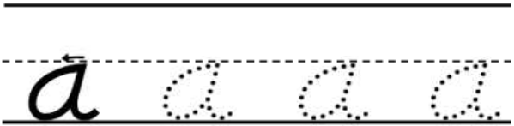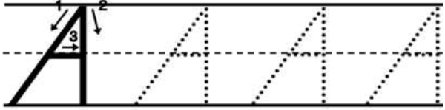Name:_______________________________________________