  INCLUDEPICTURE "http://student-zone.freeservers.com/shape-rectangle.gif" \* MERGEFORMATINET | Rectangle
 | Square
 | Circle
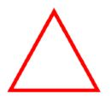 | Triangle

