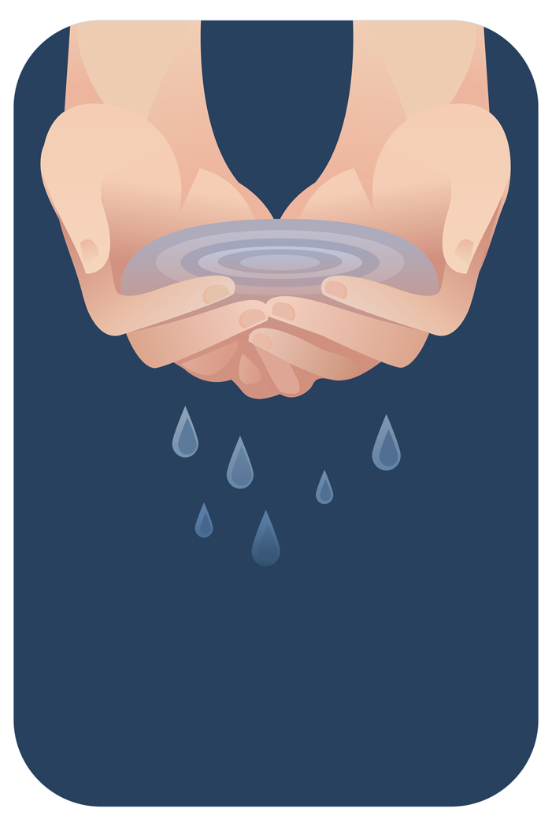 | Water  (Liquid State)
Ice
(Solid State)
Water Vapor
(Gas State)
The State of Water

