**Presidents of the United States**

T K K X F N Q B N N X P E D S N J S O U L A N L T

G L F W O W R Y F P J L H T A Z M N P Q G B O H Q

N U E G E A J M Y P G I Y M E A C J O J Q R T M F

Q E F V I T V M C S H M U E D O V T Y W L A N P N

B I T U E H P F T L F R N A B J C W W G L H I W D

W G D L T S R X J Q T E Y I N Y F O Z E N A L D E

E W C G H X O J O Y G C P V Z T B U G R T M C W B

T L E V E S O O R D N I L K N A R F W A N L M X J

T K M L A W C R R I V G F G F B O J J L A I A N S

B H X D Y C A D U E Z D O V W A O P T D R N I O F

G U O B L H I Q F X R Z T C Y H B E B F G C L T W

P E K M H N N E G F R O E E N X F X H O S O L G O

Z W O K A H M I L L A R D F I L L M O R E L I N O

L S L R O S R V G Z X N K O W F F G F D S N W I D

K F P J G D J W M X A E D C E C H J Q B S A R H R

S E B W K E T E N U N T F R V H G M B M Y V N S O

A W J E Q M B L F N K S G J E F T R F C L O I A W

J P I R X M L U E F H M U P Q W Y B Z X U D T W W

F U F Q O W U D S V E R X T R C J T C I M B B E I

Z T P P C Q Y U W H C R K G G Z A O W J U E Y G L

R K A N D R E W J A C K S O N A S X H Q U X Z R S

S Y V I N G P A N O S N H O J B N O D N Y L V O O

N O X I N D R A H C I R O K N P A H M X S R Q E N

J A M E S M O N R O E U H A T K T S H Y Z O D G F

C W K S X X G N Q L R L L J B D A Z O B M E N N U

ABRAHAM LINCOLN

ANDREW JACKSON

ANDREW JOHNSON

FRANKLIN D. ROOSEVELT

GEORGE BUSH

GEORGE WASHINGTON

GERALD FORD

HARRY TRUMAN

JAMES MONROE

JOHN F. KENNEDY

JOHN QUINCY ADAMS

LYNDON B.JOHNSON

MILLARD FILLMORE

RICHARD NIXON

THEODORE ROOSEVELT

THOMAS JEFFERSON

ULYSSES GRANT

WILLIAM CLINTON

WOODROW WILSON

Top of Form

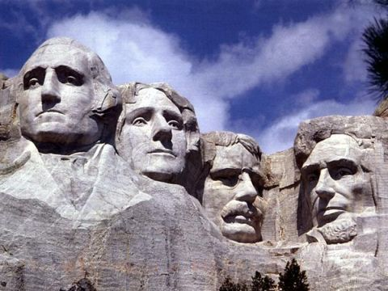

*[](http://www.discoveryeducation.com/)*