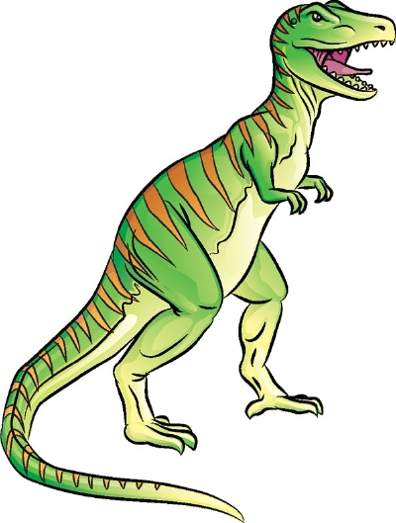**DINOSAURS**

G F C Q D Q A B Z X F H N S R

M N T C N I T X E G S E A M F

Z J O G O B N C I E S R S S Q

S K L R P V O O K B Q B E M F

L K I H T T R I S C Q I L A M

X A C I R S P O A A W V A L K

X Y R O H S A R C O U O C L T

Z T M G R Y N L L L M R S X Y

E Q O V E I F S B D X E S X H

O O H G V Q P L A N T S V K N

C R H O X E U X E E G L S Y T

N X R F M T A P E G G S Q Y S

Q E L C Y S C T H K T R S W K

S E E R T A H S N P Z G Q K D

E B Y K Y F D T N M A R B C Q

CARNIVORE HERBIVORE SLOW

LARGE DINOSAURS SMALL

PLANTS EGGS SPIKES

ROCKS EXTINCT TEETH

SCALES FAST STRONG

TREES