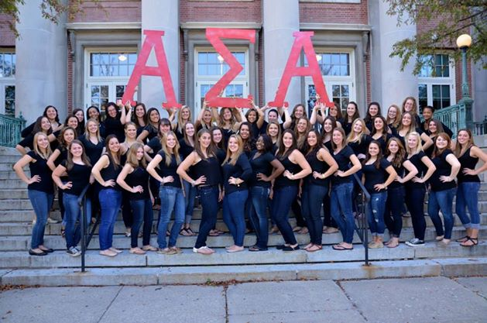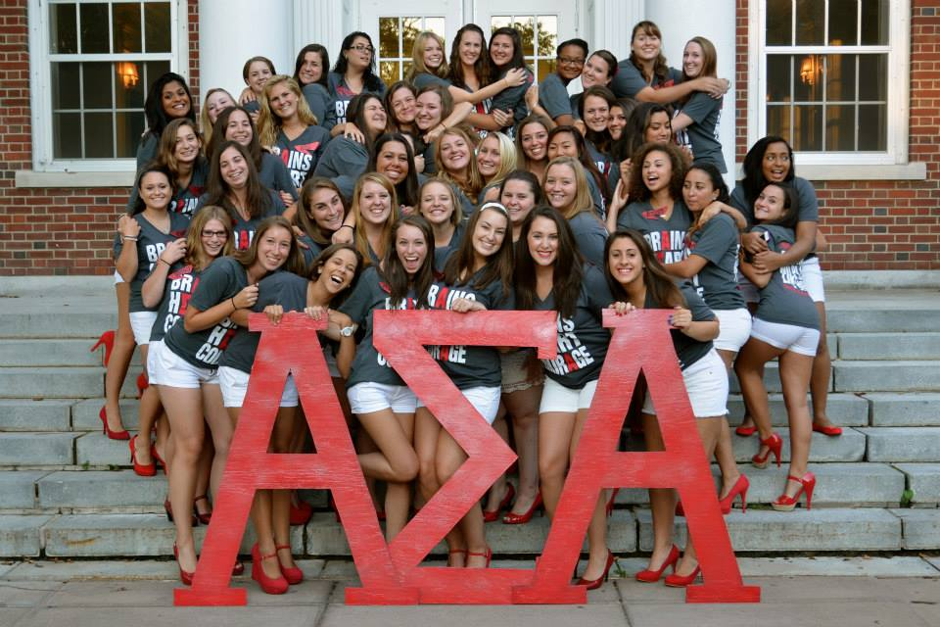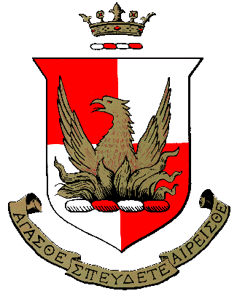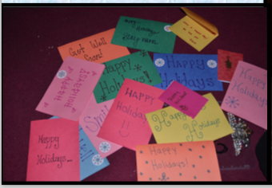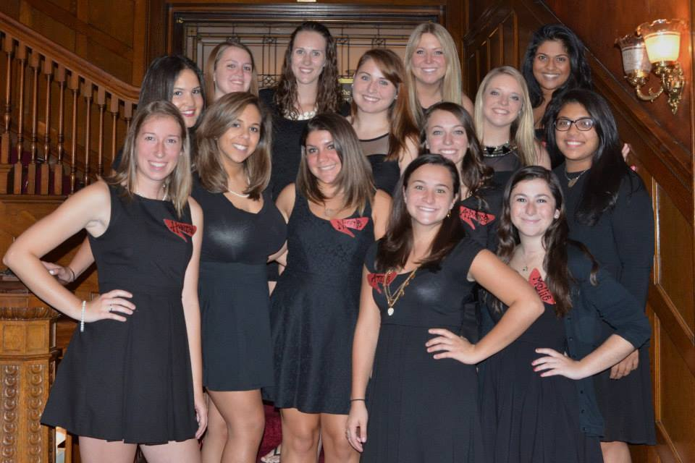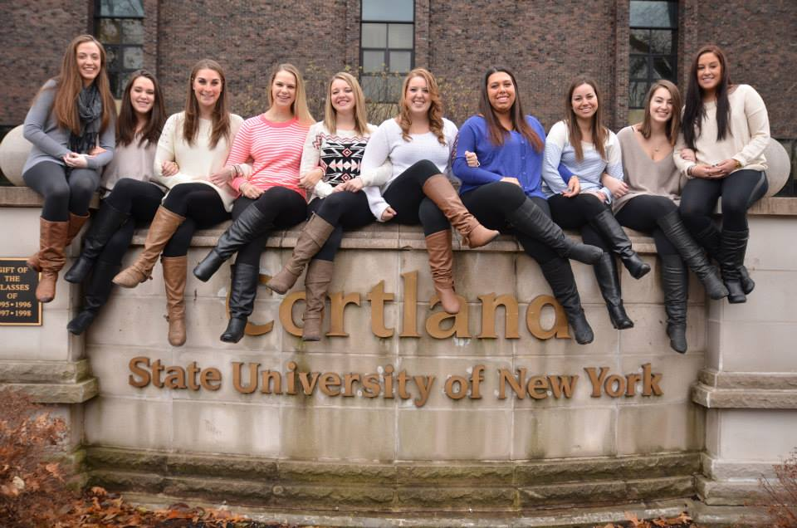

We also participate in a number of walks throughout the semester. We always do the Breast Cancer Walk, Relay for Life, a suicide prevention walk and a variety of others. We are always raising money to support local charities and making donations to those in need.

We have four philanthropies   
that we work with!

* ASA foundation
* Girls on the run
* S June Smith Center
* Special Olympics

I wear my letters on my front because my sisters have my back!

RUSH Alpha Sigma Alpha

Gamma Clio

🙞 🙜

# Philanthropy

**How much does it cost?**

Dues cost around $250 a semester but depends on the amount of active sisters.

**What are the some of the events?**

We have meet and greets as well as philanthropy events where we make cards or play fun games.

**How long is recruitment?**

Recruitment lasts for one week in the spring, and for up to three in the fall because events are more spread out.

**What should I wear to recruitment?**

Wear what you feel comfortable and confident in but still try to look nice!

**COME GET TO KNOW US!**

# Aspire, Seek, Attain.

**BASIC FACTS ABOUT ASA**

The four colors associated with our organization are palm green, gold, pearl white, and crimson. Our open motto is "Aspire, Seek, Attain" which coincides with our Greek letters.

The purpose of Alpha Sigma Alpha is, "to foster close friendships between members and to develop women of poise and purpose." Lastly, our insignia are the palm tree, star, crown, and phoenix.

We currently have 95 active sisters. This number changes each semester depending on the number of new members that are initiated and also the number of seniors who graduate. Our campus is allowed to have a total of 100 members at a time in each Greek organization.

In a normal recruitment we will take anywhere from 10 to 30 girls depending on the turn out and also how much room we have in our sisterhood.

## Q&A