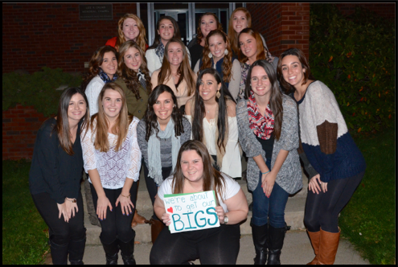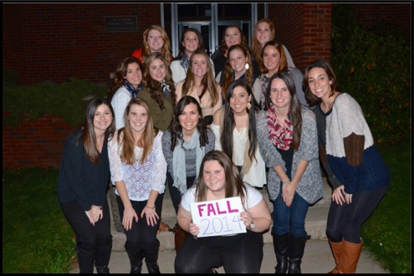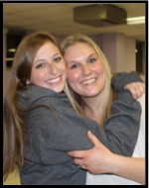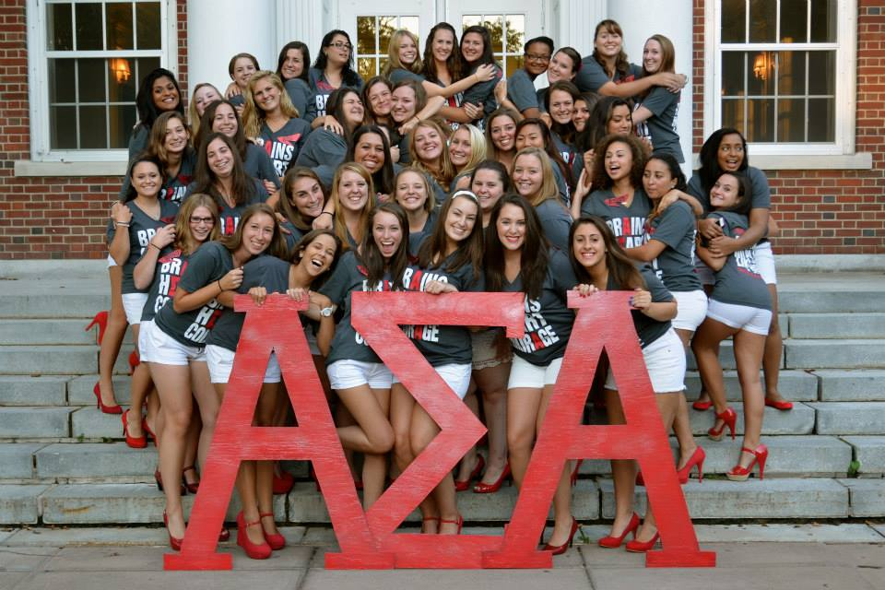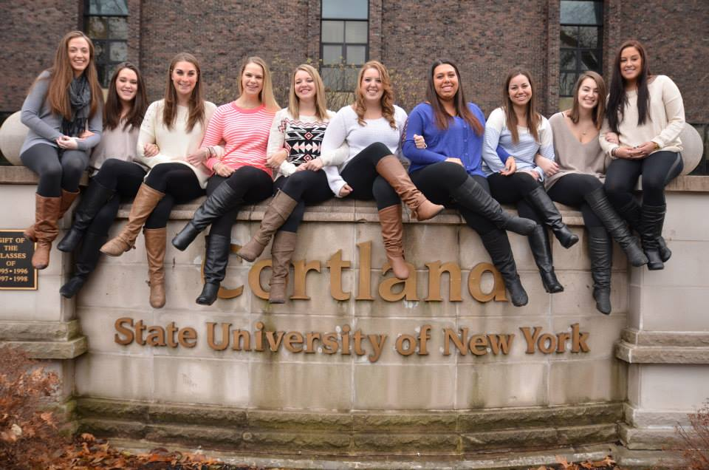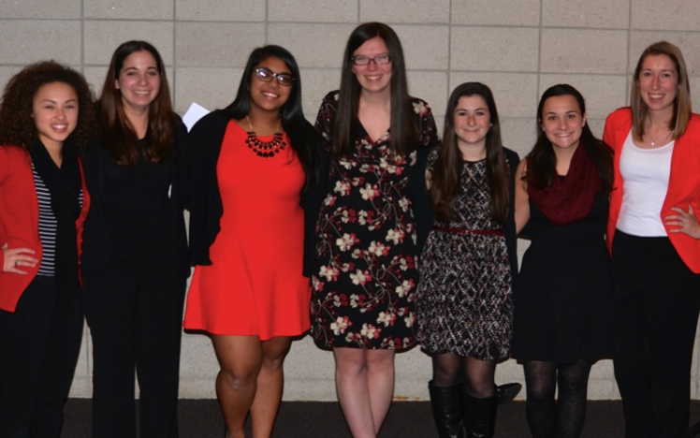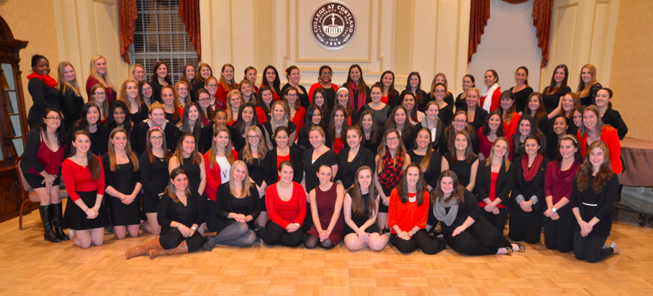

**ALPHA SIGMA ALPHA  
GAMMA CLIO   
AT SUNY CORLTAND**

December 2014

Gamma Clio goes to district days!

Sharing gifts from Secret Sister at this months Sisterhood Event

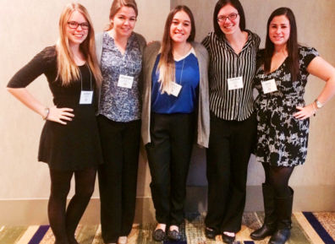

PLACE PHOTO HERE,

OTHERWISE DELETE BOX

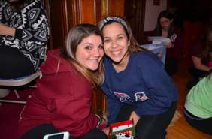

**Finals Week**

With the last chapter being over, and the semester coming to an end, it only means one thing. FINALSSSSSS!!! Don’t stress out though, study, get enough sleep, and turn to your sisters if you need them. That is what they are there for. Once this week is over, its home for the holidays so make sure to say your goodbyes for now, and get home safetly. Don’t forget to ask sisters if you need a ride home!

**Ugly Sweater Weather**

The annual Ugly Sweater Christmas party has been a tradition for a few years now at the mansion. This year was no stranger to all of the fun. With such a successful holiday party this year, it was a great way to welcome the holiday season. There were a plethora of ugly sweaters at this years party including some hanukkah themed ones as well as the classics. The holidays are a time for all of us sisters to come together, and what better way than putting on hideous sweaters from the salvation army and hanging with your best friends.

**Sisterhood & Hot Cocoa**

The last sisterhood event of the semester has come and gone. From sharing secret sister gifts, to gingerbread house making contests, fun was had by all at this holiday gathering. There was also lots of hot cocoa and snacks to go around. For this we have to thank Gabby and her committee for such a great job! Sisterhood events are a great way to step back from the frustrations of school, and relax and maybe catch up with a sister you haven’t seen in a while.

Vol. 1 Issue 1

GAMMA CLIO MONTHLY

December 2014

**OUR NEW PERFECT PAIRS**

Rachel T & Rebecca B

Rebekah S & Rachel B

Alyssa T & Hannah S

Caitlyn W & Jenna S

Sabrina V & Erica L

Paola P & Shannon L

Ginny M & Katelyn L

Amber F & Kayla

Maureen M & Taylor L

Dilara K & Michelle S

Melissa L & Sydney C

Caitlyn A & Caroline F

Dorisell A & Samantha D

Arissa V & Lauren B

Allison A & Alexis R

**Congrats Bigs and Littles**

Perhaps one of the most exciting memories you will have is the day you received your big/little. For fifteen of our sisters, that day has finally come. This is your chance to foster a relationship that will last forever. Your little or big is that person you can turn to for anything.

This year’s recruitment theme following the Wizard of Oz theme, was extremely sucessful. We would like to thank our VP of PR and Recruitment, Carynn Rich, as well as our VP of Member Education, Carleigh Mavin, for all they have done to make this recruitment season as successful as it was.

**THE MOMENTS BEFORE THE BIG REVEAL**

Vol. 1 Issue 1

GAMMA CLIO MONTHLY

**“WE WEAR OUR LETTERS ON OUR FRONT, BECAUSE OUR SISTERS HAVE OUR BACKS.”**

December 2014

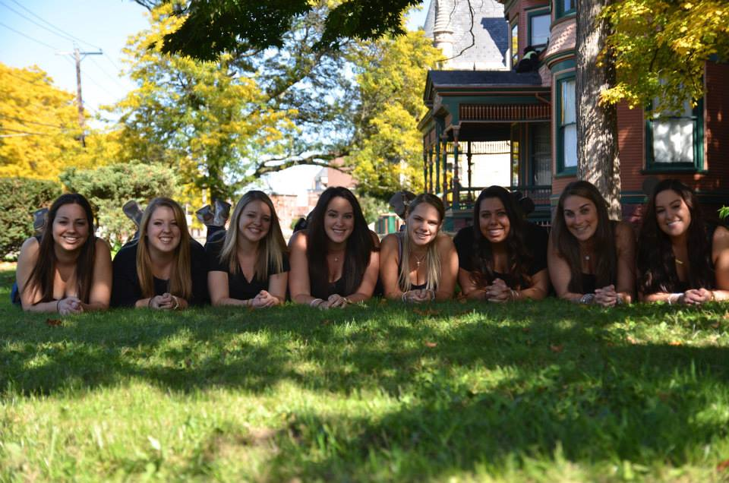

PLACE PHOTO HERE,

OTHERWISE DELETE BOX

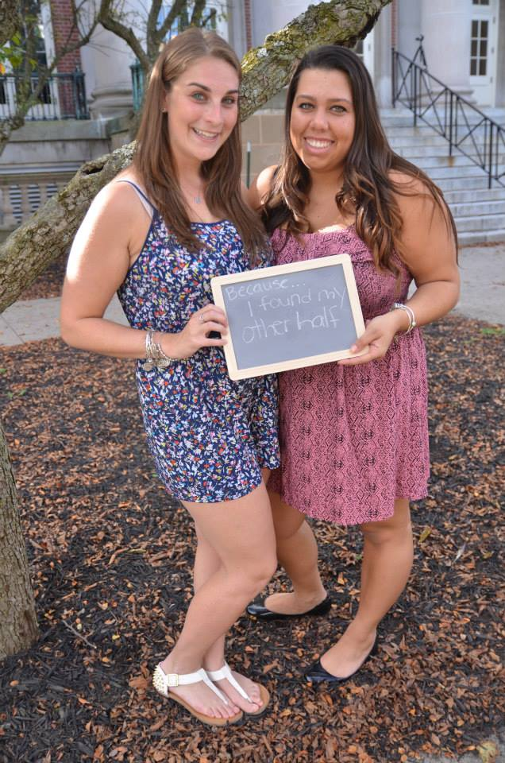

PLACE PHOTO HERE,

OTHERWISE DELETE BOX

**It’s Not Goodbye,  
 It’s See You Later**

The end of the semester means the end of college forever for some of the sisters of Gamma Clio. We would like to take the time to thank you for all you have done for the sisterhood and also for leaving your mark in Cortland Forever. We wish you all the best in your future endeavors and hope you decide to come back for alumnae events.

Don’t forget about the thousands of memories you have made here, and all the friends you will have for the rest of your life. Your time spent as a sister will stay with you forever. The connections you have made can help you in the long run, so keep in touch with your sisters. You never know when one of us will come back into your life again.

Onward and Upward ladies! ALAM

GAMMA CLIO MONTHLY

Vol. 1 Issue 1

December 2014

**WELCOME TO OUR NEW EXECUTIVE BOARD**

At the end of this month we welcomed our new executive board. This young ladies were chosen by our sisters to represent us and lead our sorority. We would like to congratulate these ladies and also thank the outgoing officers for the past year. Officer transition is such an important part of this process and we hope everyone had a wonderful time at the officer transition luncheon this past weekend!

The New E-Board is as follows:

President: Caroline Rhoads

VP of Programming and Ritual: Kaitlyn Espina

VP of PR and Recruitment: Mollie Blafer

VP of Membership Education: Annie Galliani

VP of Alumnae and Heritage: Michelle Kopec

Treasurer: Arissa Vargas

Secretary: Hannah Willis

GAMMA CLIO MONTHLY

Vol. 1 Issue 1