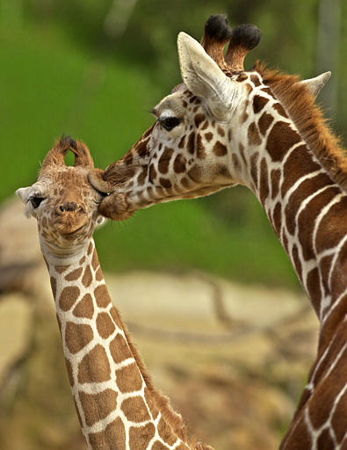 | Head-body length 12-15 ft.  Height to horn tips 15-17 ft.; weight 1700-4200 lbs (males).  Females are a foot or two shorter and a couple of hundred pounds lighter than males.
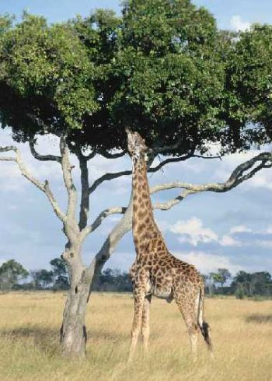 | Giraffes eat mostly leaves, flowers, vines and herbs.  An average of 16-20 hours per day are spent eating
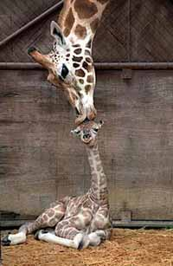 | Giraffes form scattered herds, the compositions of which are constantly changing. Although sociable, the individual is the social unit in giraffe society.  Home ranges are large, about 46 sq. miles.
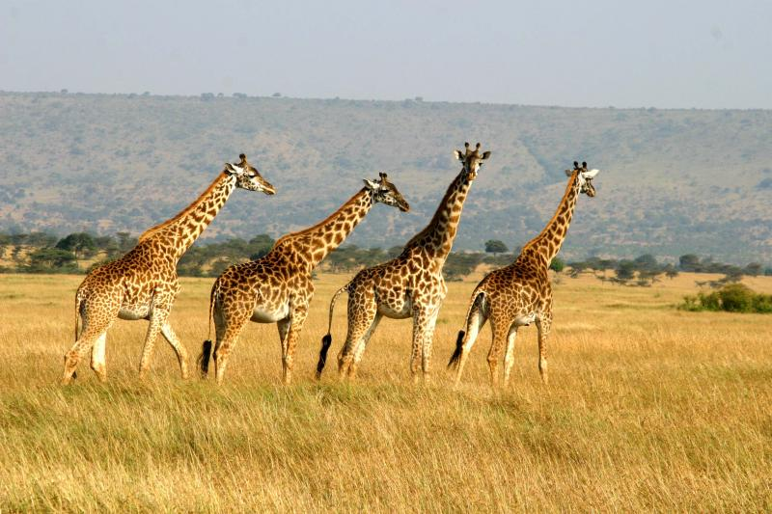 | Gestation is about 15 months  Calves are born in special calving grounds from a standing female, thus dropping some 6 feet to the ground.  Birth weight is 100-150 pounds; height is 6 feet  They can stand on wobbly legs about five minutes after birth and begin to feed about 20 minutes later.  Life expectancy is 25 years
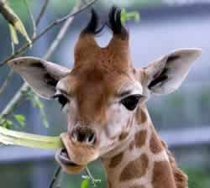 | Giraffe drink water if it is available but can go weeks without it  They rely on the morning dew and the water content of their food  To keeping track of predators, their extreme long-range visual acuity enables visual communication with other giraffe over several miles.  Giraffe can run at speeds up to 35 mph.

