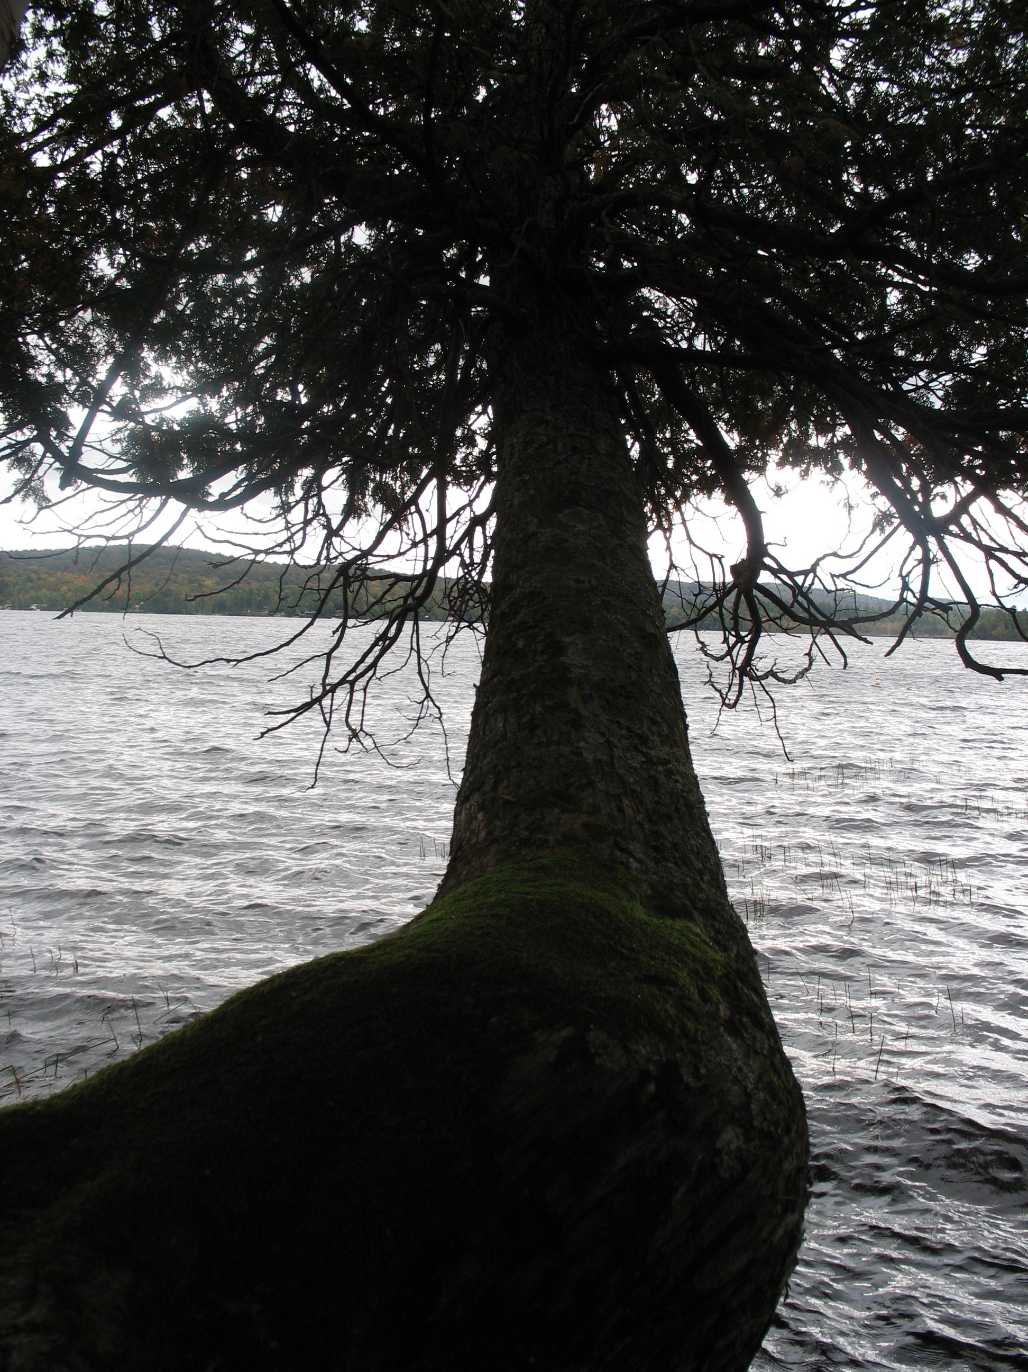

Raquette

Lake

N Q P J C S D C T F Z M T A V
E K A L W E D R L C Y T A A Z
B Q M I X I O A L A R H O W O
W Y I E K R L R O E S S B N N
R I V D B O Q Y E T X S A J B
A O F H E T O D E D F H U V F
E G H N W S D N A H C F Y N T
P R A O T H I A S R M A F C H
O X I M I L G O M L R U V Q O
C E R F P B W L O T W T E X A
K M G I P C H U R C H K S B M
O E Z W M M G H E J I W T A N
L E N E N E A Z O H D F I F O
D O Z A O X J C X D U B U P I
Y C G W X U T Y I M V M T P T

BOAT LAKE
HIKE SMORE
CAMPFIRE STORIES
TREE CHURCH
TOAD
CLASS

