**Winter Fun**

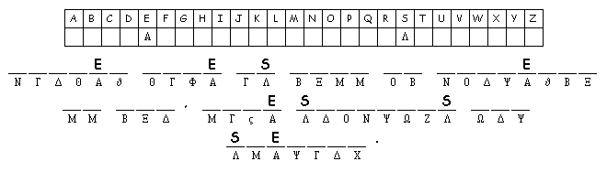

*[](http://www.discoveryeducation.com/)*

Created by [Puzzlemaker](http://puzzlemaker.discoveryeducation.com) at DiscoveryEducation.com