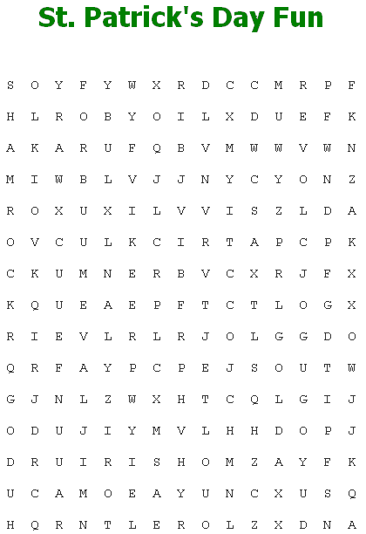

**CLOVER**

**GOLD**

**GREEN**

**IRELAND**

**IRISH**

**JIG**

**LEPRECHAUN**

**LUCK**

*[](http://www.discoveryeducation.com/)*Created By

**MARCH**

**PATRICK**

**RAINBOW**

**SHAMROCK**