To The Moon

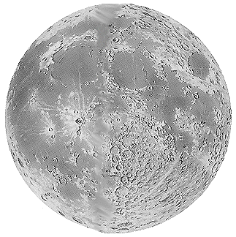  C | T | N | I | R | P | T | O | O | F | E | A | R | T | H
S | O | S | T | F | A | R | C | E | C | A | P | S | Y | E
C | N | M | R | K | G | A | L | F | I | S | O | H | X | N
I | A | C | M | I | M | N | T | B | L | T | L | P | J | W
E | C | A | Y | U | F | Q | M | A | C | R | L | A | M | O
N | I | P | L | G | N | U | D | O | O | O | O | R | Q | D
T | R | S | U | X | L | I | L | P | R | N | L | G | L | H
I | E | U | J | O | R | L | C | A | B | A | O | O | I | S
F | M | L | C | O | I | L | T | A | I | U | R | T | F | A
I | A | E | L | N | Y | I | U | F | T | T | T | O | T | L
C | W | F | S | A | O | T | G | W | Z | I | N | H | O | P
N | I | X | O | N | R | Y | M | O | O | N | O | P | F | S
S | T | N | E | M | U | R | T | S | N | I | C | N | F | S
R | E | N | D | E | Z | V | O | U | S | E | L | G | A | E
A | R | M | S | T | R | O | N | G | N | I | R | D | L | A

ALDRIN | AMERICAN | APOLLO
ARMSTRONG | ASTRONAUT | CAPSULE
COLLINS | COLUMBIA | COMMUNICATION
CONTROL | EAGLE | EARTH
EXPLORATION | FIRST | FLAG
FLORIDA | FOOTPRINT | INSTRUMENTS
JULY | LIFTOFF | MOON
NIXON | ORBIT | PHOTOGRAPHS
RENDEZVOUS | SCIENTIFIC | SPACECRAFT
SPLASHDOWN | TRANQUILLITY

Created by Puzzlemaker at DiscoveryEducation.com

