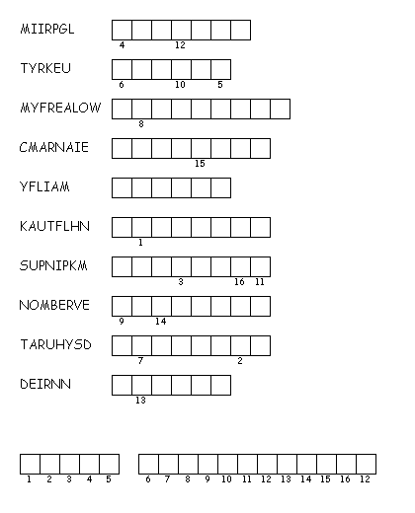
Unscramble each of the clue words.
Copy the letters in the numbered cells to other cells with the same number.
Thanksgiving Scramble

Created by Puzzlemaker at DiscoverySchool.com

