**Word Art Acrostic Name Poem**

**K**ind

**I**ndependent

**M**ysterious

**B**old

**E**nergetic

**R**esponsible

**L**ucky

**Y**oung at Heart

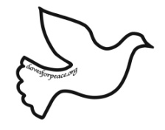

**K*I*M*B*E*R*L*Y**