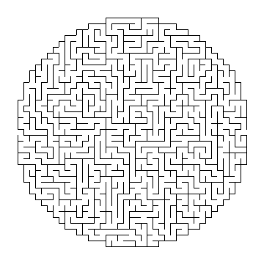

Created by Discovery Puzzle maker at DiscoverySchool.compuzzlemakerlogo