ToolBox Pro Tutorial
- Log into the school computer system using your user name and your user password. So you do not forget your password and username please record them below. Skip this step if you are logging in from your home computer.

a.Username : firstname-lastname
b.Password : your lunch id#

- Once you are logged into please go to www.toolboxpro.org

- Each of you will need a user name and password to log into the website
Your user name is 066-firstname-lastname
Your temporary password is changeme

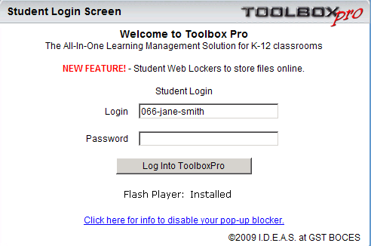

Once you log into ToolBox Pro you will be prompted to change your password. Please write down your new password.

My new password ________________________________________

- Once you are logged into the system please look for your class period and look on it. It should say period # Spanish grade 7

- Look at the top of the screen and find the resources tab and click on it.

  - This is where you can find songs, videos and web materials in Spanish. There are many interactive materials that I have pulled from the web.
  - You will also find supporting materials such as different PowerPoint presentations that we have used in class

- Go to the activities tab. This is where you will find different activities to help you prepare for tests and quizzes.

