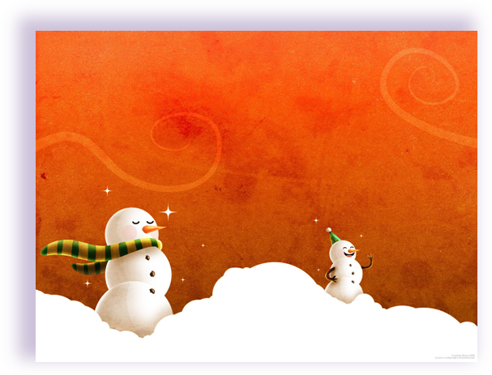
Our class will be having a holiday celebration on December 21st. In the morning we will be outside playing in the snow. So, send your child with the proper snow gear. I don’t want anyone to have to miss out on the fun! In the afternoon we will have a celebration with food and music. If your family has a special treat you enjoy around this time of year you are more than welcome to send some in to share with the class. Also, if your family has a special holiday song you enjoy please send in a copy for your child to share with the class.

If you have any questions feel free to call or email me @ s.zimmerman@elementaryschool.org

