I Bought a Pet Tomato
I bought a pet
and I tried to teach him tricks,
but he wasn't any good at
catching or fetching sticks.
He could never catch a Frisbee,
and he wouldn't sit or speak,
though we practiced every afternoon
and evening for a week.
He refused to shake or  or crawl
or beg or take a bow,
and I tried, but couldn't make him bark
or get him to meow.

He was terrible at playing dead.
He couldn't jump a .
When he wouldn't do a single trick
I simply gave up hope.
Though I liked my pet,
I returned him with regret.
Boy, I sure do hope this 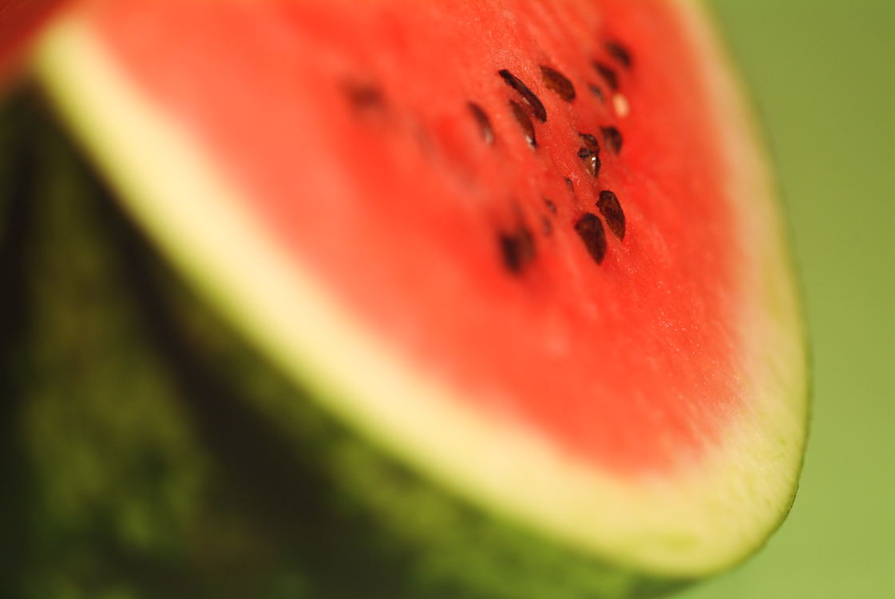
makes a better pet.
--Kenn Nesbitt

