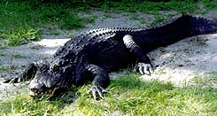 | Large stomach. Carnivorous. Eats fish, snakes, frogs, turtles, birds, and mammals such as muskrats, deer and cows. Big animals are dragged underwater and drowned and then torn to pieces. They are very efficient metabolically.
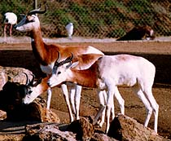 | A genuine desert animal. They mainly browse on various desert shrubs and acacias, rearing up on their hind legs to reach young shoots, but also feed on the rough desert grasses.
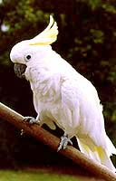 | A noisy, gregarious bird. During the breeding season, they move in pairs or family groups; the rest of the year, they move in flocks. They feed in the open during the day with sentries posted in trees. At night they return to an habitual roosting site, usually along a watercourse. Nests are built in holes in trees or cliff sides. Clutch size is 2 to 3. Both parents incubate the eggs for 30 days. Young remain in the nest for 6 to 9 weeks.
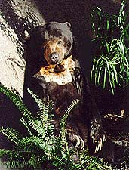 | Smallest bear. Omnivorous, using front paws for most of feeding activity. Trees are torn open in search of wild bee nests and for insects and their larvae. Also eat rodents, lizards, small birds, fruit, soft growing parts of palm trees and honey.
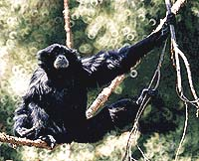 | Largest of the lesser apes. Height: up to 3 feet. Weight: 20 to 45 pounds (Sumatran male is largest). Color: jet black, with long, profuse, somewhat shaggy hair. Face is naked with sparse stubble of moustache and beard. Armspread up to 5 feet. Forearm hair grows toward elbow as in great apes and humans. Dark eyes, color vision, and a throat sac inflatable to the size of the head (gular sac). The toes are webbed between 2nd and 3rd toes. No facial fringe or tail.
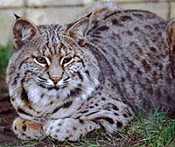 | Often confused with lynx, but with these differences: they have a longer tail with a black bar on the upper side fringed with white hairs; it also has shorter and more slender legs with small, less thickly furred paws and ear tufts less visible. Usual color is a shade of buff or brown spotted with dark brown and black. Common in desert country; those from forests are darker. Females have 4 nipples.

