New England States and Their Capitals

Connecticut  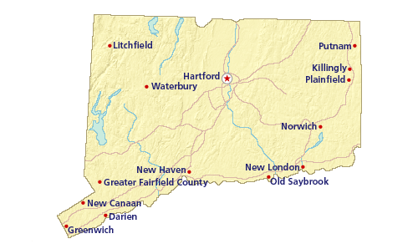 | Hartford

Maine | Augusta

Massachusetts  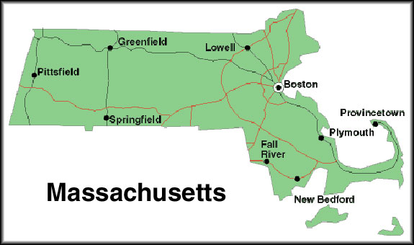 | Boston

New Hampshire  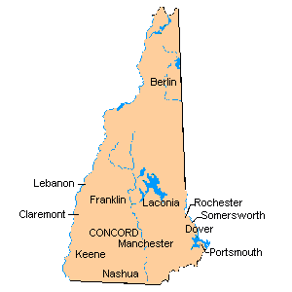 | Concord

Rhode Island  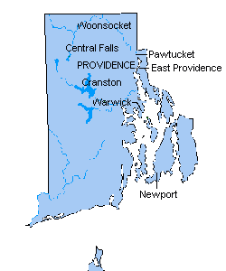 | Providence

Vermont  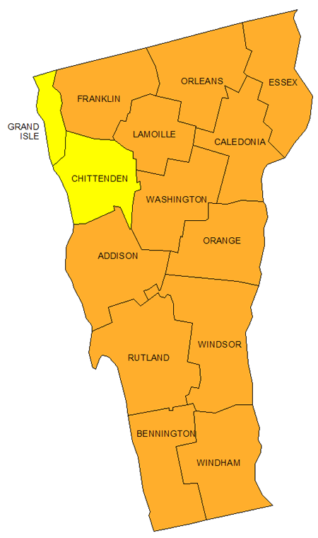 | Montpelier

