Welcome to Open House

Mrs. Wood’s Room

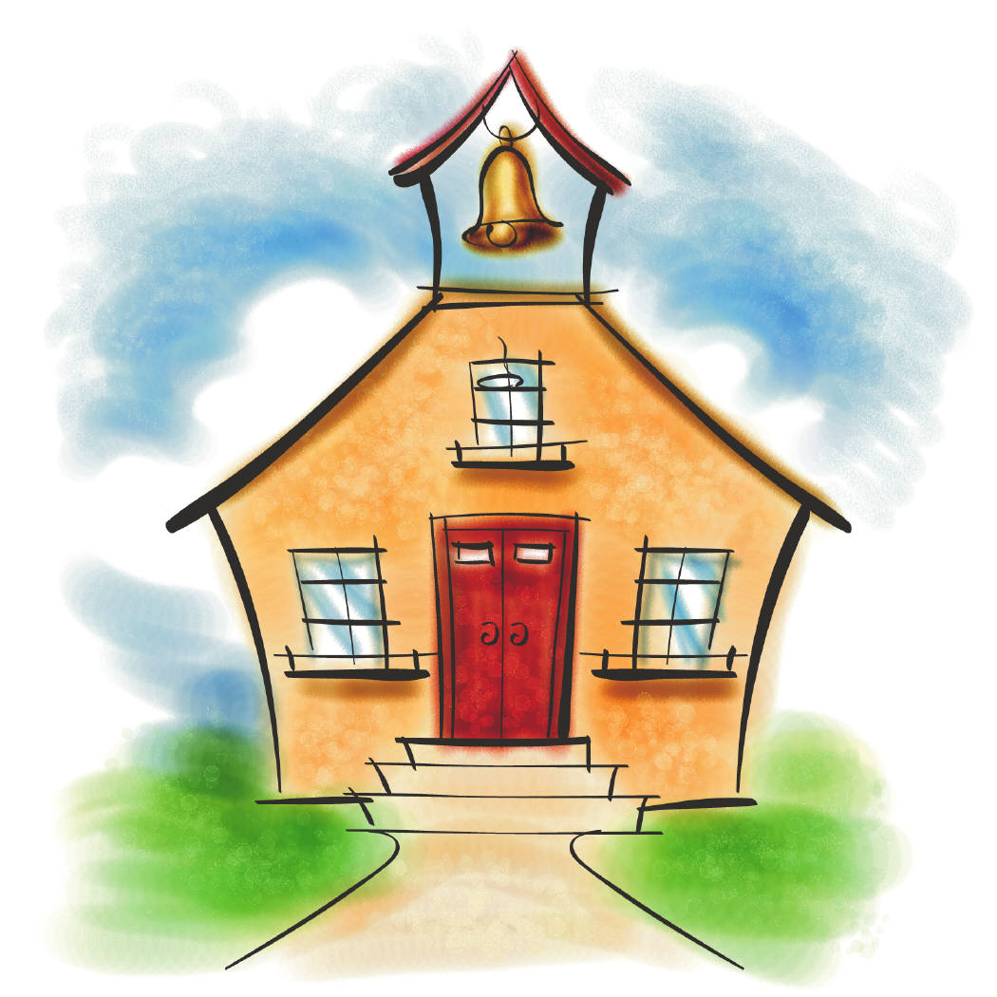

Please enter and find your child’s desk. Your child has left a special note for you to read on the desk. Please respond and leave the note on the desk for him/her to read tomorrow morning.

Thank you.

Presentation to begin at 6:00PM